

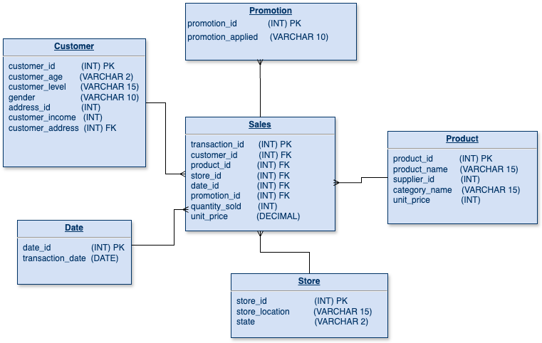

4 Steps to Create a Star Schema

* Identified the fact table

I selected the Sales table as the fact table. It includes all the important numbers for analysis, like quantity_sold, unit_price, and IDs to connect with other tables.

* Created the dimension tables

I made separate tables for Customer, Product, Store, Date, and Promotion.

* Flattened the dimension tables

I simplified the dimension tables by removing unnecessary layers. I added category_name directly to the Product table instead of linking it to another table.

* Linked the tables

I connected the fact table to the dimension tables using foreign keys. For example, customer_id in the fact table links to customer_id in the customer table.

This completed the star schema, with the fact table in the center and the dimension tables around it

|  |  |
| --- | --- |
|  | |

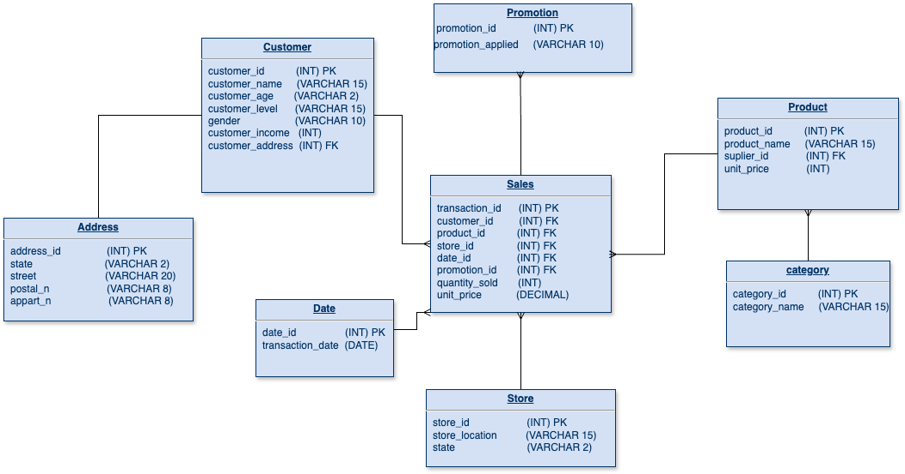

Normalization Steps

* Started with the Star Schema

I began with the star schema I created earlier. The Sales table is the main fact table, and it connects to dimension tables like Customer, Product, Store, Date, and Promotion.

* Added extra table

I split some dimension tables into smaller, more detailed tables to avoid repeating data:

In the Product table, I moved category_name into a new table called Category. The Product table now links to the Category table using category_id.

In the Customer table, I moved address details (like state, street, postal_n, and appart_n) into a new table called Address. The Customer table now links to the Address table using address_id.

* Kept the fact table the same

The Sales table stayed the same. It still contains foreign keys (customer_id, product_id, store_id, date_id, and promotion_id) to connect with the dimension tables. Maybe in the future I will change this and add more data to this db

* Linked new sub-tables

I connected the new, smaller tables to their parent tables using foreign keys:

Product links to Category through category_id.

Store links to State through state_id.

Customer links to Address through address_id.